UML Diagram

Below are the documented uml diagrams which were used to start planning on the project

1. DFD
   1. Level 0 _Draft-1

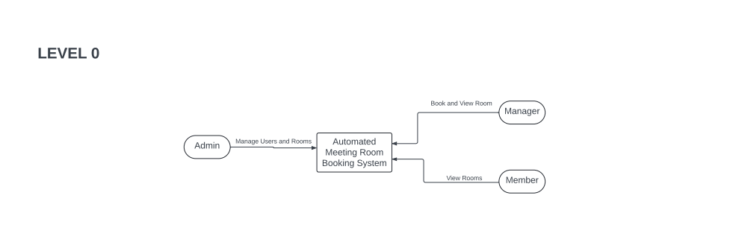

* 1. Level 1 _Draft-1

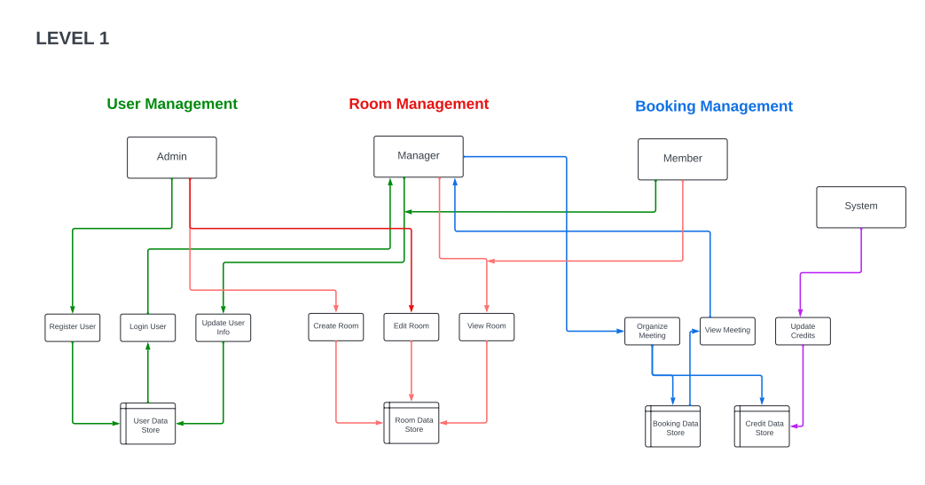

* 1. Level 2 _Draft-1

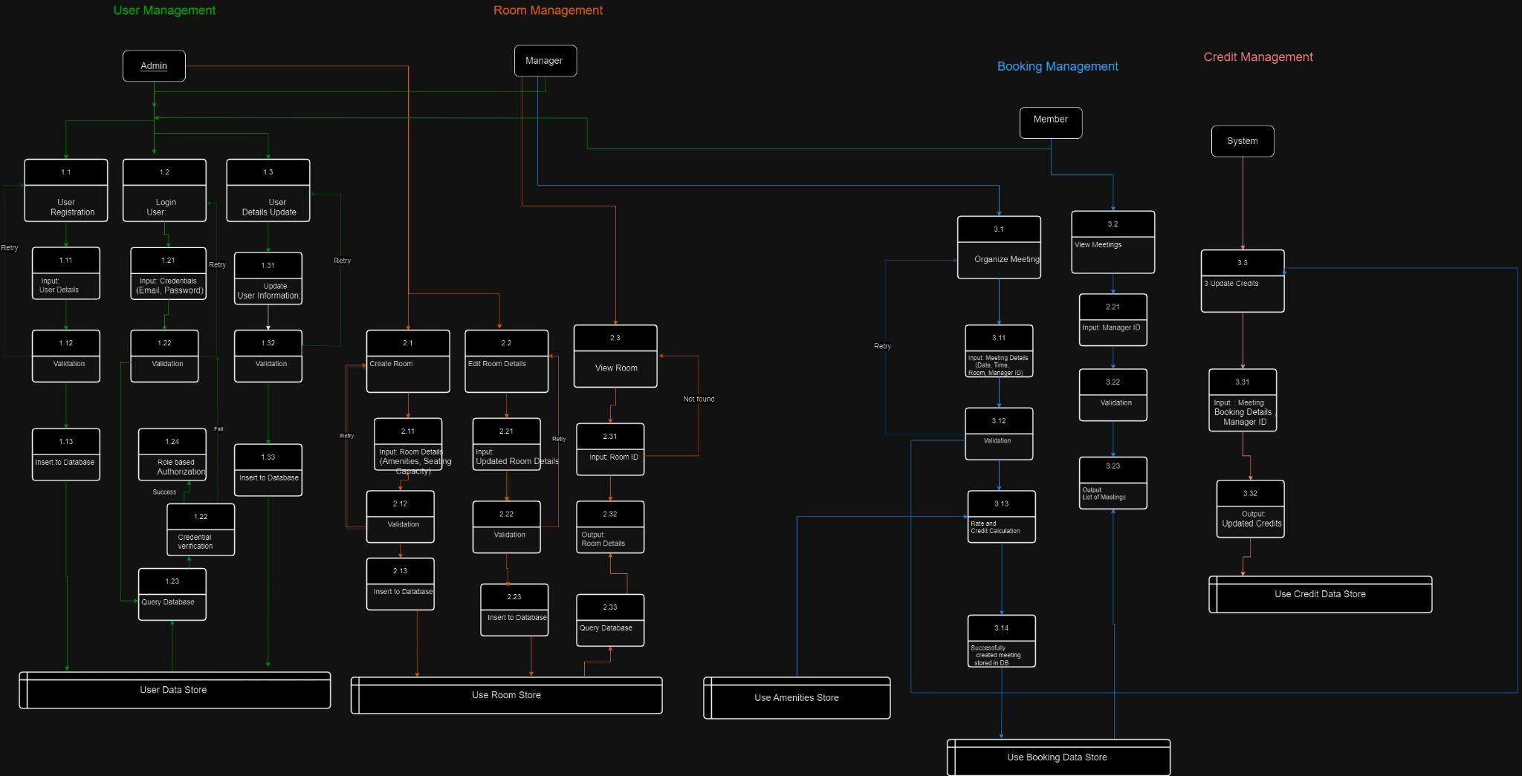

1. Use Case Diagram _Draft-1

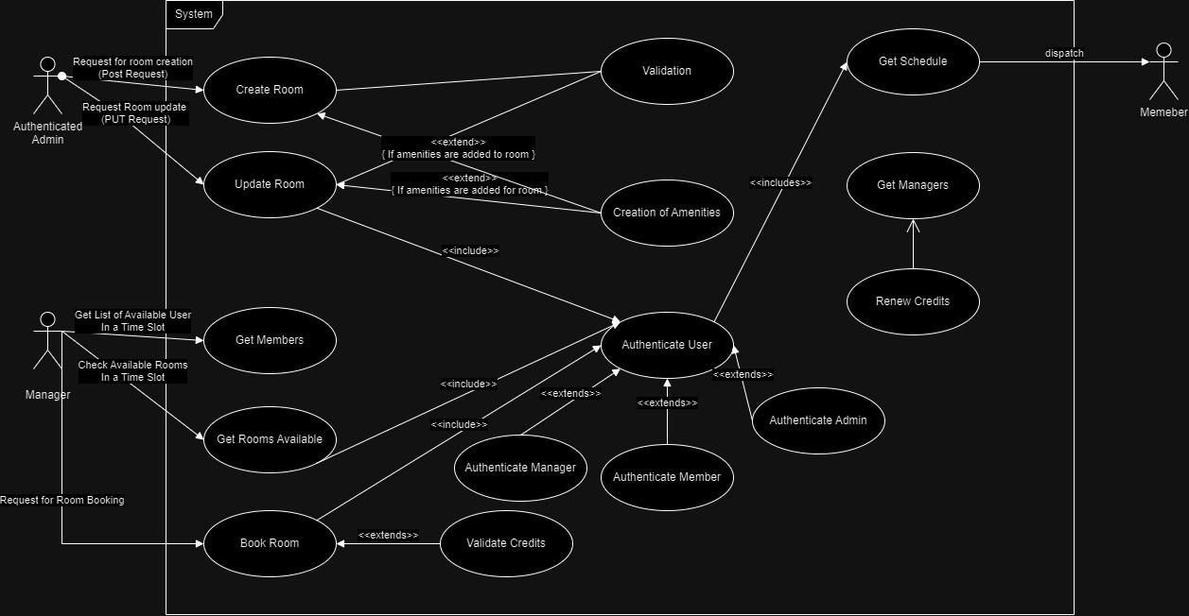

1. Package Diagram _Draft-1

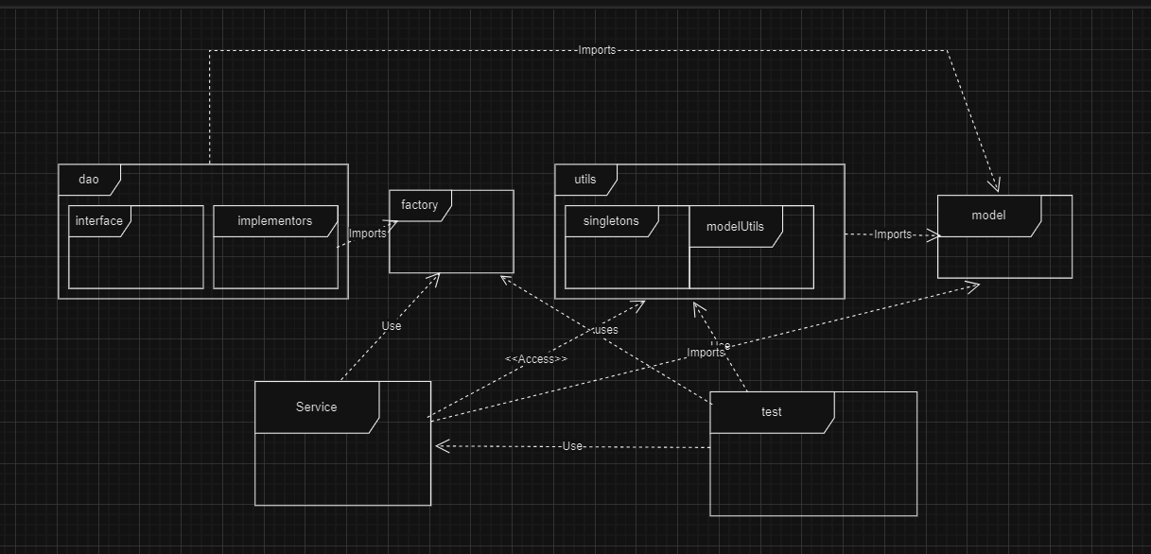

1. Class Diagram _Draft-1

Final results

1. Package Diagram/ Module Diagram

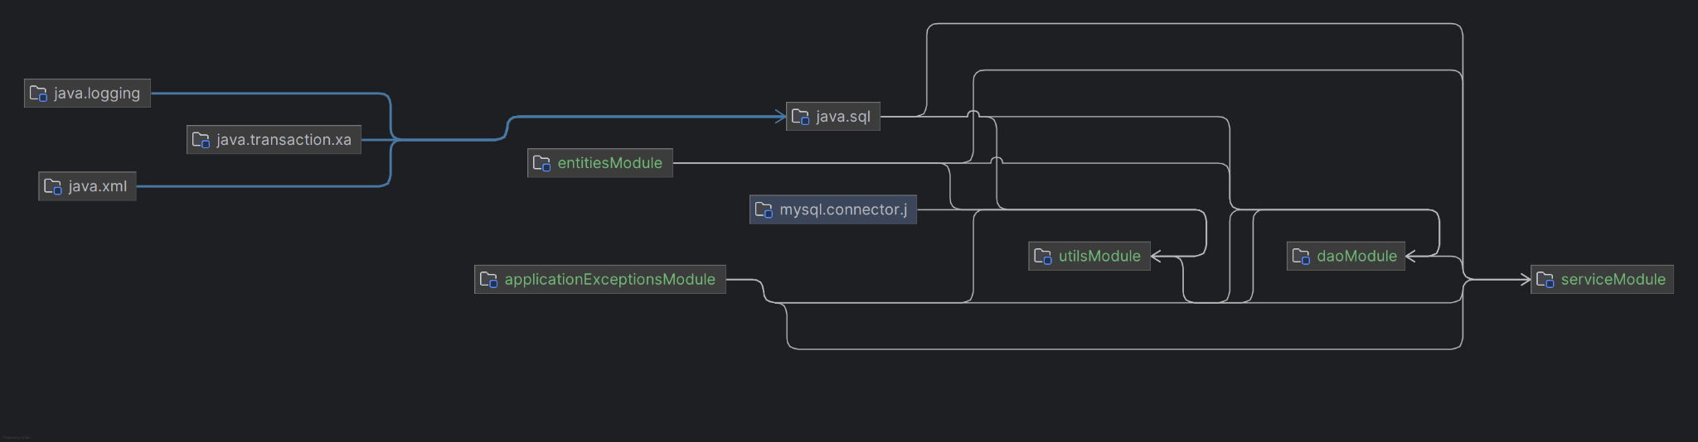

1. Class Diagram

Draft - 0

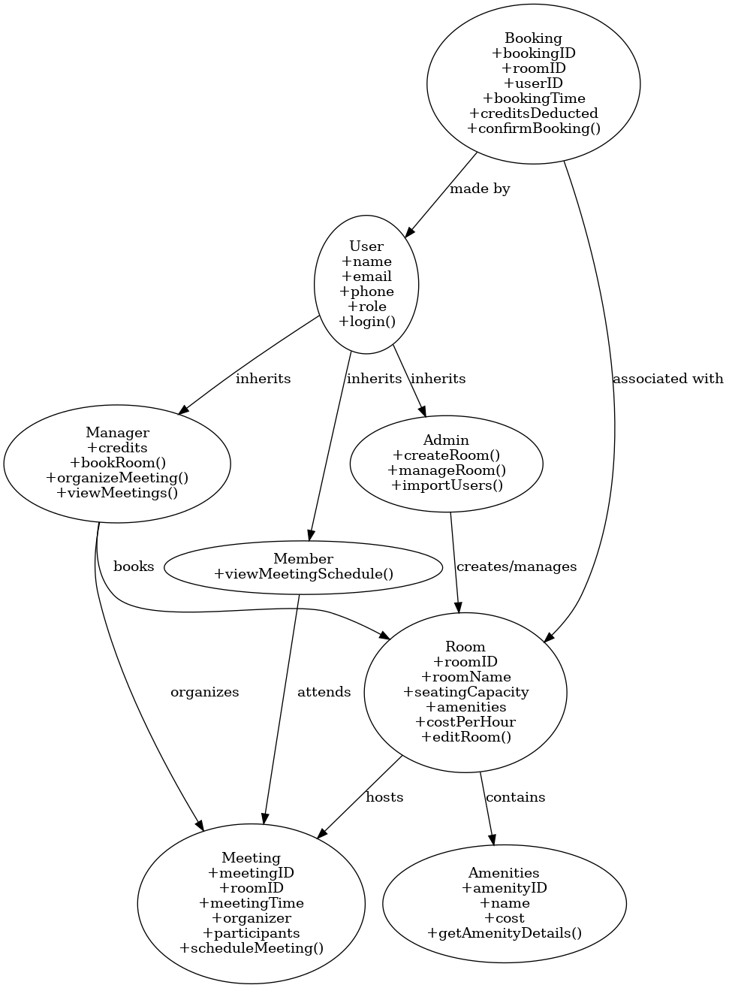

Draft -1

1. 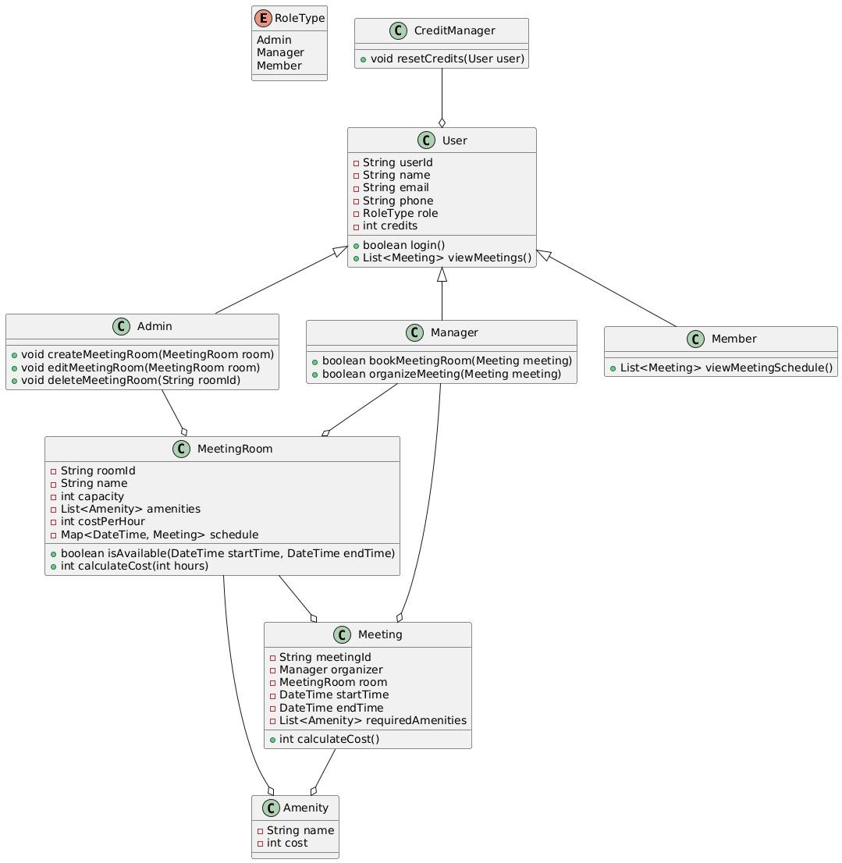
2. 